**POSIZIONE GEOGRAFICA VILLA VIRGINIA**

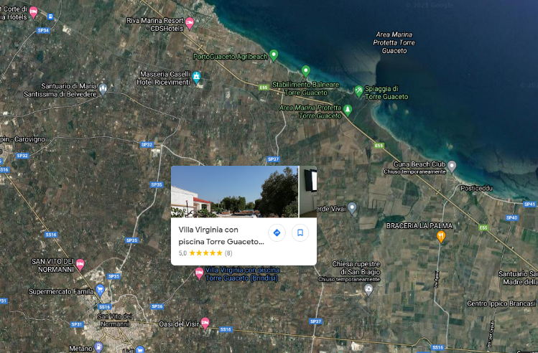

[**https://maps.google.com/maps?q=40.6685277%2C17.7362662&z=17&hl=it**](https://maps.google.com/maps?q=40.6685277%2C17.7362662&z=17&hl=it)